**Mini Project Report on**

https://lh5.googleusercontent.com/ohvai7KPoKAEUNYsicFH0XLU7ciQxvy6iRS7HFnAyWgLJCBAGHOZdZSocRCUV4jszqYCebC7WB4CeEcQfTA-KRdKW_o5t6S1prlh5JP_xM-YNaQLbf9wuXVpuRaRsQb3nXwgcLzQ_KOjNOpgKb1PA9YcFVPdSPrQtkrBR0f6H5ZmpNjDcGaRW2csWmHh4dHg2sB5dEF_Zw

**LIBRARY MANAGEMENT SYSTEM**

https://lh5.googleusercontent.com/ohvai7KPoKAEUNYsicFH0XLU7ciQxvy6iRS7HFnAyWgLJCBAGHOZdZSocRCUV4jszqYCebC7WB4CeEcQfTA-KRdKW_o5t6S1prlh5JP_xM-YNaQLbf9wuXVpuRaRsQb3nXwgcLzQ_KOjNOpgKb1PA9YcFVPdSPrQtkrBR0f6H5ZmpNjDcGaRW2csWmHh4dHg2sB5dEF_Zw

**Submitted in partial fulfillment of the requirement for the award of the degree of**

**BACHELOR OF TECHNOLOGY**

**IN**

**COMPUTER SCIENCE & ENGINEERING**

**Submitted by:**

**PRIYANSHI KAMBOJ**

**2016928**

***Under the Mentorship of***

**Ms. Meenakshi Maindola**



**Department of Computer Science and Engineering**

**Graphic Era (Deemed to be University)**

**Dehradun, Uttarakhand**

**January 2023**



I hereby certify that the work which is being presented in the project report entitled **“LIBRARY MANAGEMENT SYSTEM”** in partial fulfillment of the requirements for the award of the Degree of Bachelor of Technology in Computer Science and Engineeringof the Graphic Era (Deemed to be University), Dehradun shall be carried out by the under the mentorship of **Ms. Meenakshi Maindola**, Department of Computer Science and Engineering, Graphic Era (Deemed to be University), Dehradun.

**Priyanshi kamboj    2016928**

**ACKNOWLEDGEMENT:**

Here by I, ‘PRIYANSHI KAMBOJ’ , am submitting the project report on **“LIBRARY MANAGEMENT SYSTEM”** as per the scheme of Graphic Era Deemed University, Dehradun.

I would also like to express my gratitude to my mentor Ms. Meenakshi Mandola mam and all the faculty members of the computer science department for their constant encouragements and much needed support for the successful completion of the project.

Finally I am very much thankful to all , friends and my parents for their constant encouragement, support and help throughout the period of project conduction.

**Date-04/01/2023**

**PRIYANSHI KAMBOJ**

**2016928**

**Table of Contents**

|  |  |  |
| --- | --- | --- |
| **Chapter No.** | **Description** | **Page No.** |
| Chapter 1 | Introduction | 04 |
| Chapter 2 | Features of the  library management  system | 07 |
| Chapter 3 | Tools Used | 08 |
| Chapter 4 | Modules | 09 |
| Chapter 5  Chapter 6 | Tools  Conclusion | 12  14 |
|  |  |  |

**Chapter 1**

**Introduction :**

**1.1 what is library management system:**

Library Management System Project is primarily concerned with library membership and data management. Member’s Login and Librarian Login are the two sections of the project.

And this is where things get a little more interesting, as in real-life scenarios.

Members must request and await approval from the librarian for a variety of tasks, including registration.

The concept is similar to a real-life situation and is well-implemented as a web application. .

As a result, the librarian plays an important role in the system’s management.

Presenting a new library management system project with essential features to follow while remaining knowledgeable for learning purposes.

Users can customize the features of this Simple library management system project to meet their specific needs.

**1.2 Advantages:-**

* The system excludes the use of paper work by managing all the book information electronically thus, this system reduces manual work to a great extent allows smooth flow of library activities by removing chances of errors in the details.
* Admin can keep updating the system by providing the new books arrival in system and their availability thus students need not to go to library for issuing purpose.
* The system has books well organized and systematically arranged in different categories in the system so that user can easily search and find the book.
* It allows both the admin and the student to search for the desired book. It becomes necessary for colleges to keep a continuous check on the books issued and returned and even calculate fine.
* Thus, it saves human efforts and resources.

**1.3 MOTIVATION FOR DOING THE PROJECT:-**

A library management is a project that manages and stores books information electronically according to students needs.

The system helps both students and library manager to keep a constant track of all the books available in the library.

It allows both the admin and the student to search for the desired book.

It becomes necessary for colleges to keep a continuous check on the books issued and returned and even calculate fine.

This task if carried out manually will be tedious and includes chances of mistakes.

These errors are avoided by allowing the system to keep track of information such as issue date, last date to return the book and even fine information and thus there is no need to keep manual track of this information which thereby avoids chances of mistakes.

Thus this system reduces manual work to a great extent allows smooth flow of library activities by removing chances of errors in the details.

**Chapter 2**

**ABOUT**

**2.1 Main design of Library Management System**

The main objective of Online Library Management System is developing a computerized system to maintain all the daily work of the library. It has two sides –

1. User side (student / teacher).
2. Admin side.
   1. **Some other features:**

* Membership Verifications by Librarians according to the Librarian Login Manual.
* Request for a book Make a list of all the books you’ve borrowed.
* New book records should be added.
* Current book records should be updated.
* Showcase the books that are available.
* Remove the books from the shelves.
* Maintain a list of membership registrations that haven’t been completed yet.
* Organize your pending book requests.
* Reminders about book due dates can be found here.
* Members’ balance should be updated.
* Penalty is deducted automatically if a book is returned after the due date.
* Responsiveness

**Chapter 3**

**TOOLS USED:-**

|  |  |
| --- | --- |
| **Project Platform :** | PHP |
| **Programming Language Used:** | PHP |
| **IDE Tool (Recommended):** | Sublime, VS Code |
| **Project Type :** | Web Application |
| **Database:** | MySQL |

**Chapter 4**

**MODULES:**

* 1. **HOME PAGE:**

The main page which contains the description of all the webpages associated with the main page. The user can get some information about the library e.g. - closing times, contact information etc. It contains the link to surf the platform and visit various other parts of the website.

* 1. **Admin login**:

Admin is the one who administers the system by adding or removing e-books into and from the system respectively.

Admin is also responsible for approving or disapproving the book requests made by the students or teachers.

* 1. **User login:**

Students have to register themselves into the system to create an account. After registering successfully, they can then login into the system by entering the username and the password.

* 1. **Add and Update Books**:

The admin can add books to the system by entering the details of the books and can even update the details.

* 1. **Search option:**

 Admin and Students can even search for books by entering the name of the book.

* 1. **Forgot password**:

If the user has forgot the password he/she can retrieve it using forgot password page by which they can create a new password by entering the essential credentials.

* 1. **New user/ Sign in page**:

If you are a new user and you don’t have any username or password then you can sign up in the website using the sigh up page.

* 1. **View Order**-

The admin can view order for the books i.e. how many order requests are pending to be approved .

* 1. **Place order**-

The students can place order for the books and simultaneously the quantity of the book ordered will be decremented.

**4.10Calculate Fine**-

The student can view the issue and expiry date for the book issued and can even calculate fine.

**Chapter 5**

**TOOLS**

**5.1 HTML:-**

HTML is the standard markup language for creating Web pages. The webpages of this project have been created using HTML.

**5.2 CSS:-**

CSS is the language we use to style an HTML document.

CSS describes how HTML elements should be displayed.

We have used CSS in our webpages to style the HTML documents used in the website.

**5.3 PHP:-**

PHP is a server-side programming language. HTML is a client-side scripting language.

PHP is used in backend development, which interacts with databases to retrieve, store, and modify the information. HTML is used in frontend development, which organizes the content of the website.

**5.4 SQL:-**

SQL is used to communicate with a database. According to ANSI (American National Standards Institute), it is the standard language for relational database management systems. SQL statements are used to perform tasks such as update data on a database, or retrieve data from a database.

**5.5 Bootstrap:-**

Bootstrap is an open source front-end development framework for the creation of websites and web apps. Designed to enable responsive development of mobile-first websites, Bootstrap provides a collection of syntax for template designs.

**5.6 SCREENSHOTS:-**

**5.6.1 Home Page**



**5.6.2 Sign Up**

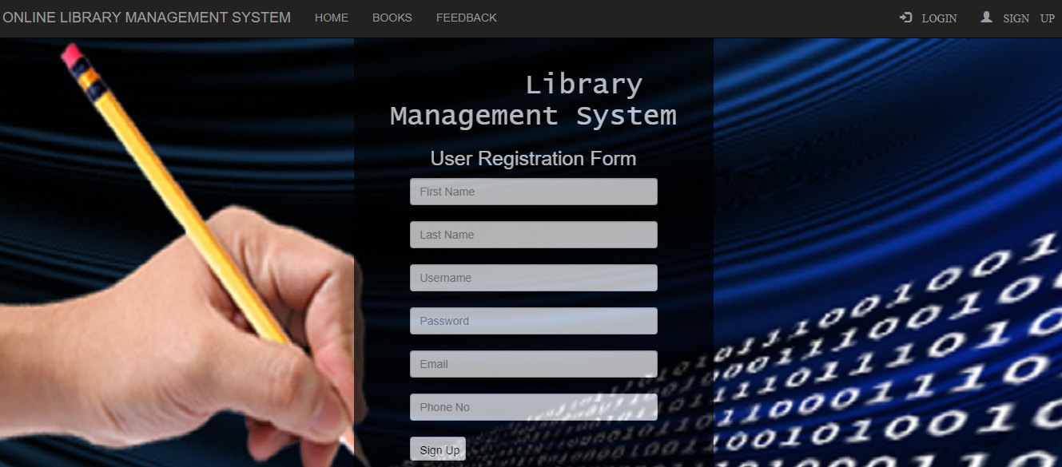

**5.6.3 Student Record**

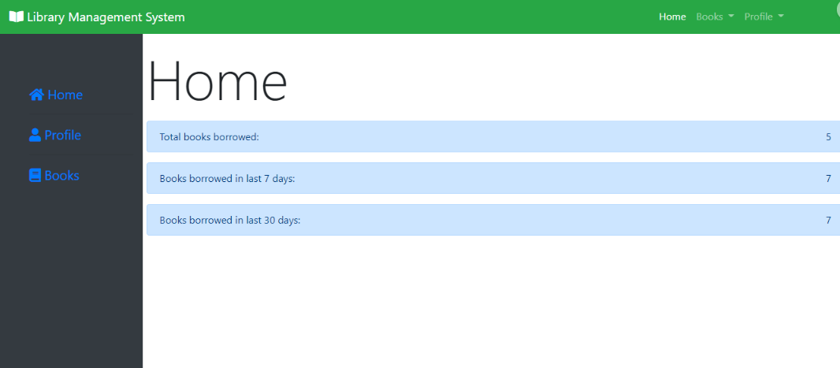

**5.6.4 Books**

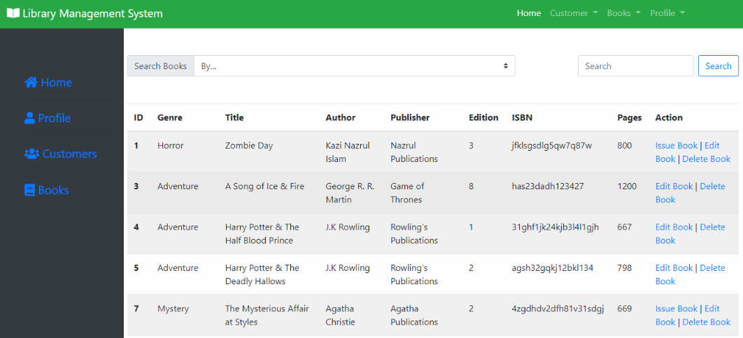

**5.6.5 Feedback:-**

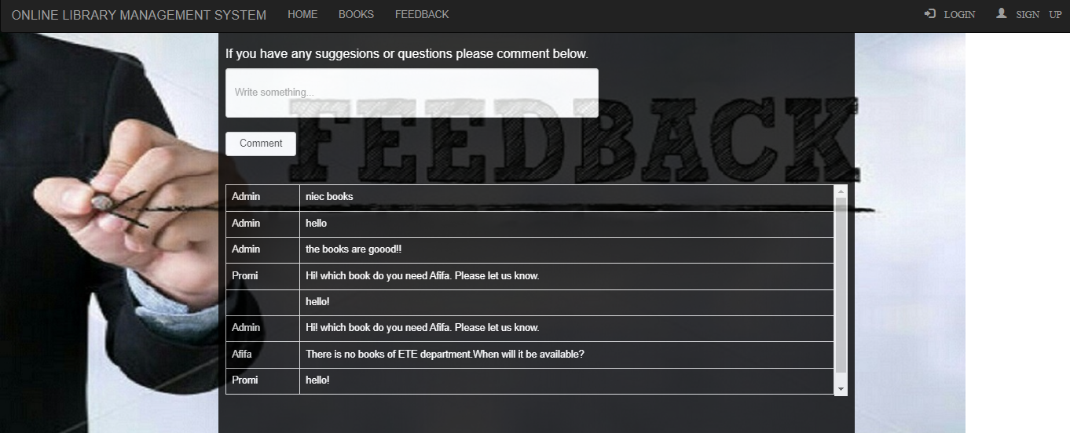

**Chapter 6**

**CONCLUSION:-**

**6.1 The conclusion of the project:**

The delivered system “LIBRARY MANAGEMENT SYSTEM” software has been designed to achieve maximum efficiency and reduce the time taken to handle the handwritten lists.

Furthermore, it is designed to replace an existing manual record system thereby reducing time taken for calculations and for storing data.

The system is strong enough to withstand regressive daily operations under conditions where the data is cleaned over a certain time of span.

The implementation of the system in the organization will considerably reduce data entry time and also provide readily calculated reports. The System has adequate scope for modification in future if it is necessary.

The project has helped me know about the various tools and technologies that are available in the field of development and the project was not just theoretical but a real life based that we can easily connect to.

Overall working on this project was great fun as I came up with great piece of knowledge and understanding of the topic and I am excited to work further on such other projects in upcoming semesters.